

1401_04 - Run PO SMD - on multiple makers and one packer based on MC messages

Process Definition Document (PDD)

**Document History**

| Date | Version | Role | Name | Organization | Function | Comments |
| --- | --- | --- | --- | --- | --- | --- |
| 19.11.2019 | 1.0 | Author | K.NIROSH | ITC Infotech |  | PDD V1.0 |
|  |  |  |  |  |  |  |
|  |  |  |  |  |  |  |

**Contents**

**1** **Process key contacts 4**

**2** **Minimum Pre-requisites for automation 4**

2.1 Pre-requisites……………………………………………………………………………………………………………………4

**3 Test Cases (Scenario link from Teams)…………………………………………………………….4**

# 4 Components not in Scope (External System Components)…………………………...…4

**5** **Data To be used……………………………………………………………………………………………5**

# 6 As Is Process Description………………………………………………………………..5

6.1 As Is Process Overview 6

# 7 To Be Process Description

7.1 To Be Detailed Process Map 7

7.2 Deviations / Technical decision taken for automation 8

**8** **In Scope for Automation 9**

**8** **Out of Scope for Automation 9**

**9** **Business Exceptions Handling 9**

9.1 Known Exceptions 10

9.2 Unknown Exceptions9

9.3 Automation Exceptions…………………………………………………………………………………………………….10

**10** **Document Approval 10**

**11** **Screenshots of Manual Execution : 11**

**12 APPENDIX**

# Process key contacts

| Role | Name | Contact details  (email, phone number) | Notes |
| --- | --- | --- | --- |
| Manual Flow Execution | K.NIROSH | knirosh@itcinfotech.com |  |
| Test Architect | Sonai Layek | [Sonai.Layek@itcinfotech.com](mailto:Sonai.Layek@itcinfotech.com) |  |
| Automation Tester | K.NIROSH | knirosh@itcinfotech.com |  |

# Minimum Pre-requisites for automation

| S. No | Application name & version | Type | Test Data Required |
| --- | --- | --- | --- |
| 1 | Delmia Apriso 2019 Desktop Client | Desktop  Application | Username, Password |
| 2 | SOAP UI | API | Master Case XML |

## Pre-requisites



# Test Cases (Scenario link from Teams)

Find attached Excel



# Components not in Scope (External System Components)

1. SMD_POD-10_OP_Display perfomance graph for current shift
2. SMD_POD-10_OP_Display production progress vs plan for all POs for the currently running SKU

# Data To be used

| S. No | Application name | Test Data Required |
| --- | --- | --- |
| 1 | Delmia Apriso 2019 Desktop Client | |  | | --- |    Username: Dinesh |
| 2 | Delmia Apriso 2019 Web Client | Username: Dinesh |
| 3 | SOAP UI | MasterCaseInfo XML |

# As Is Process Description

This portion highlights the actual design of the business process before automation

## As Is Process Overview :



**Input** :Master case XML

**Output**: Master Case Production success in GMES

**Standard Test Data to be used** (if any) : username, password

# To Be Process Description

This portion highlights the expected design of the business process after automation.

* The symbol in the below flow chart displays the process exceptions where the workaround needs to be performed based on the below mentioned Exception Table 9.1 
* The process in the below flow chart highlighted in red explains the deviation from the maual process to perform the automation in obtaining the final end result is explained in section 6.2 of the document 
* Prequisite considered for the scenario.

## To Be Detailed Process Map



**Input** :Work center number, equipment number, production order number, Master Case XML

**Output**: Master Case Production success in GMES

**Standard Test Data to be used** (if any) : username, password

## Key Validations / Assertions

1.Successful processing of **Master case Info** xml by SOAP UI.

2.Validate if the Master case Info is processed successfully in Immediate Jobs History.

3. Validate if MC number is appearing in POD-51 screen.

## Deviations / Technical decision taken for automation

1. **Why do we use web services instead of SAP for all SAP Test cases ?**

We dont have Line System integration during GMES testing, Thus we are triggering the Idocs through web services**.** We send the messages through SOAP UI.

1. **Why menu paths is different ?**

The placement of operations under menu path varies from site to site , As in QA operator portal comes under UIUX operations

**Note**: Moving forward: Deviation/Judgement call if known in advance will be covered in PDD else it

would be captured in a supporting document and provided at the time of review and approval

signoff.

# In Scope for Automation

# 

Sending master case info message to create master cases against a running po in smd workcenter.

# Out of Scope for Automation

Line System

# Business Exceptions Handling

## Known Exceptions

* During triggering xml from SOAP UI message processing can fail due to connectivity issue or firewall issue.
* MC Info message can fail due to incorrect PO number or start date.

## Unknown Exceptions

## Desktop Client session can logout if there is session issue

* IE may not work if it is not in 100% zoom or in protected mode.

## Automation Exceptions

We are triggering the XMLs in .xml format from SOAP UI instead of idocs from Line System as we don’t have Line System integration within the scope of our testing.

# Document Approval

This document requires serial approval (sign off) from the roles defined in the table below.

Changes to the requirements must be documented in an updated version (i.e v 2.0) and requires a new signature flow.

| Version | Flow | Role | Name | Organization  (Dept.) | Approval Date: |
| --- | --- | --- | --- | --- | --- |
| **1.0** | **Document prepared by** | **Automation Tester** | Shalini Verma | ITC-Testing |  |
| **1.0** | **1st Level Approver** | **1)Tech Architect**  **2) Project Manager** | Sonai Layek | ITC-Testing |  |
| **1.0** | **Final Review** | **Test Manager** |  | BAT |  |
| **1.0** | **Sign Off** | **Test Manager** |  | BAT |  |

# Screenshots of Manual Execution :

**Component 1.** **SMD_OPP-10_OP_View production details on Operator Portal**

* 1. Launch the URL [**http://10.16.24.171/Apriso/Portal/Kiosk/Login.aspx?**](http://10.16.24.171/Apriso/Portal/Kiosk/Login.aspx?)

Username : Dinesh

Password : 9

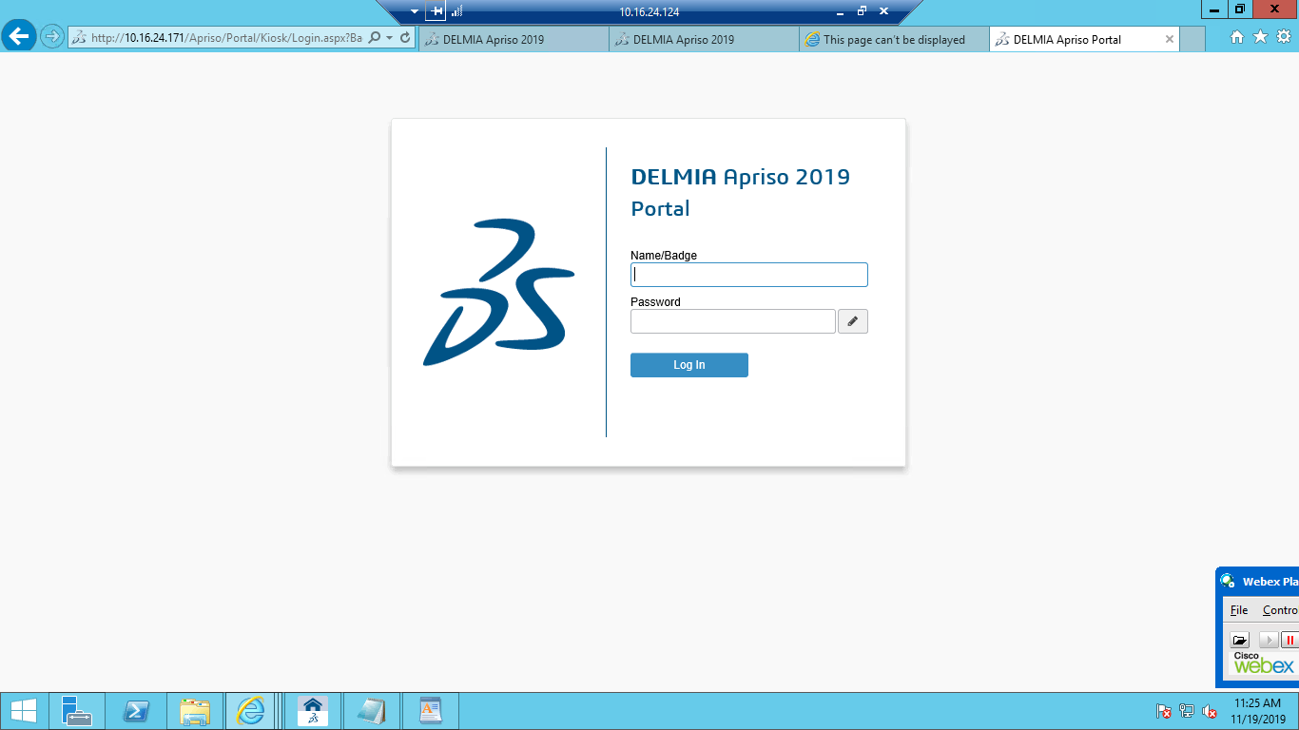

* 1. Navigate to BAT Operations 🡪 UIUX Operations 🡪 Operator Portal

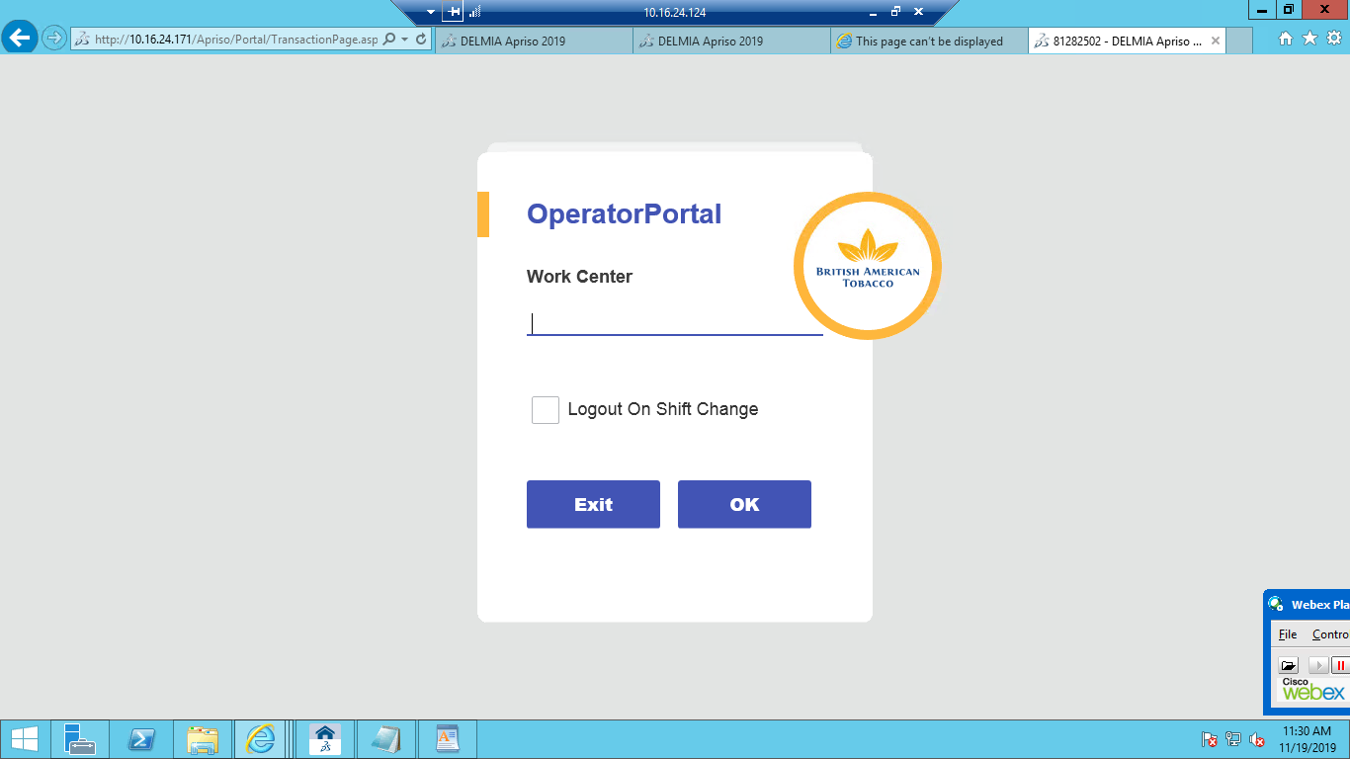

* 1. Enter Work Center (Eg. SP15) 🡪 OK

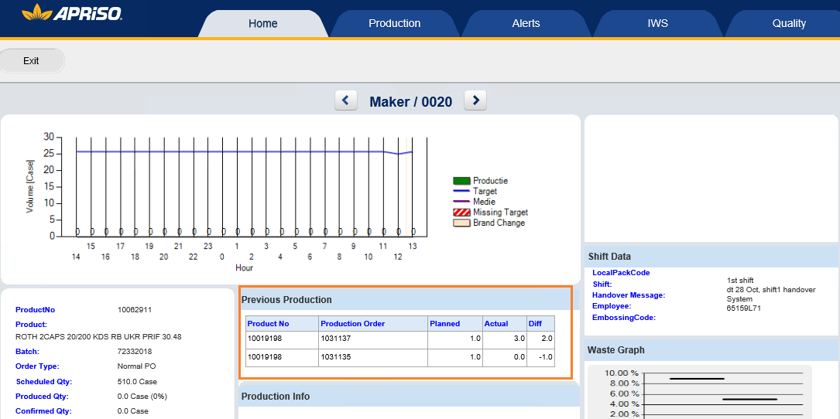

* 1. Capture“ Product No, Production order, Planned quantity, Actual quantity, Difference“ form 'Previous Production'.

**Component 2.** **EXT_Conveyor_ITF_Produce MC**

2.1. Open “mastercaseinfo.xml” file edit MasterCaseNumber, MasterCaseStatus, Equipment, TimeStamp, ProductionOrder accordingly.

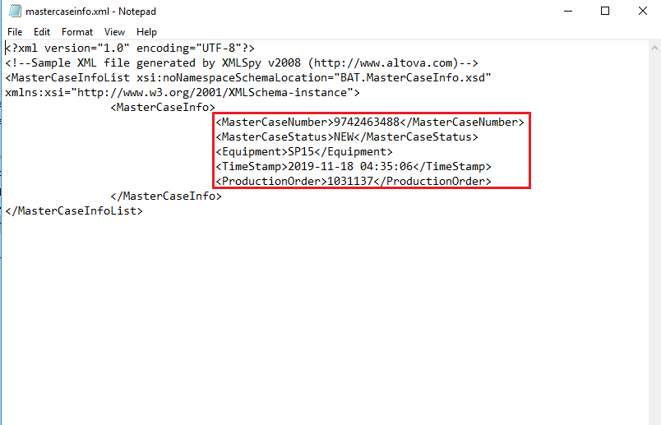

2.2. Trigger the xml from SAP to GMES (put xml in the Flexnet File Processor archive queue)

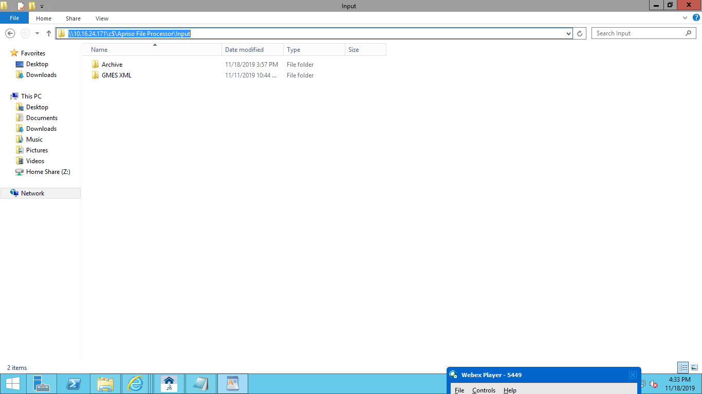

**Component 3.** **ADM_JobHistory_MM_Check Mastercase Info message**

3.1. Open Delmia Apriso 2019 Desktop Client 🡪 Enter UserName and Password

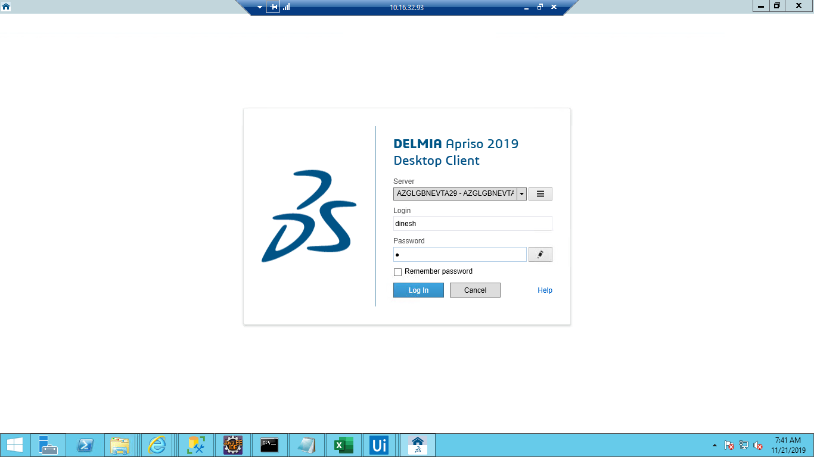

3.2. Navigate to “Immediate job History”

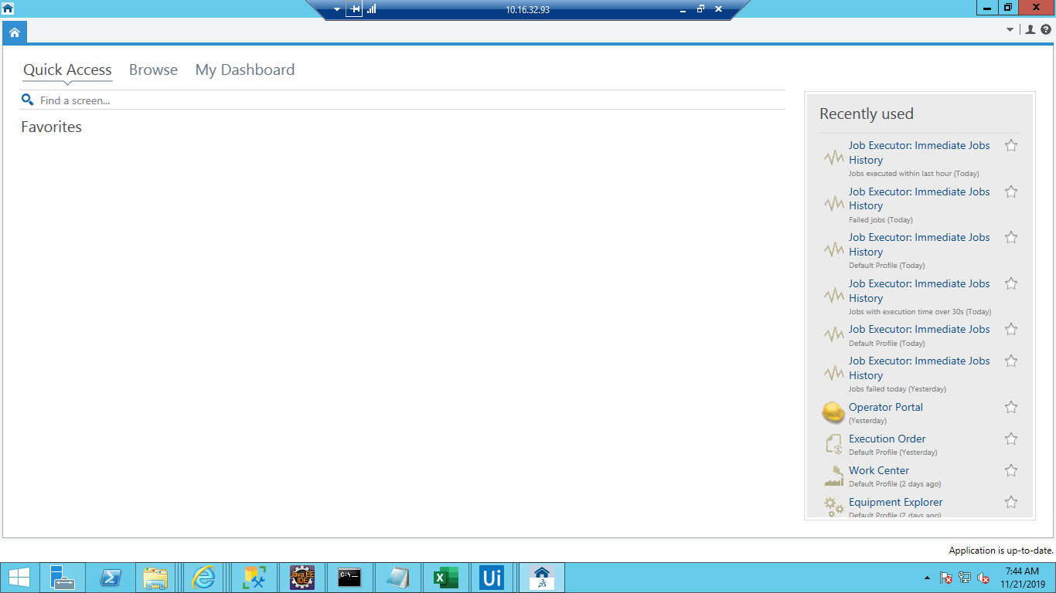

3.3. Verify "MastercaseInfoList message" in synchronization queue and MasterCaseNumber,

MasterCaseStatus, Equipment, TimeStamp, ProductionOrder.

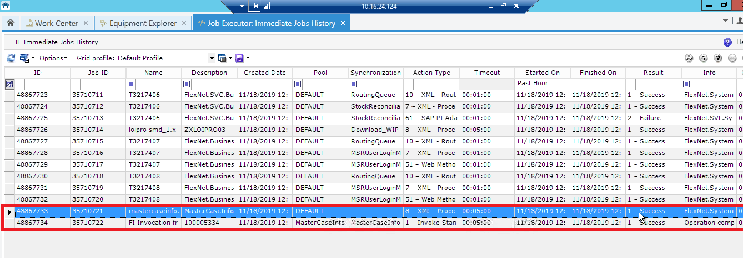

**Component 4.** **SMD_OPP-10_OP_View production details on Operator Portal**

Navigate to BAT Operations 🡪 UIUX Operations 🡪 Operator Portal🡪 Enter Work Center

(Eg. SP15) 🡪 OK and validate “ Product No, Production order, Planned quantity, Actual

quantity, Difference“ form 'Previous Production'



**Component 5.** **SMD_POD-50_OP_View produced MCs**

Navigate to SMD work center 🡪 Production Tab 🡪click on Production tracking button and

"SP15" screen is displayed listing out all produced Master Cases.

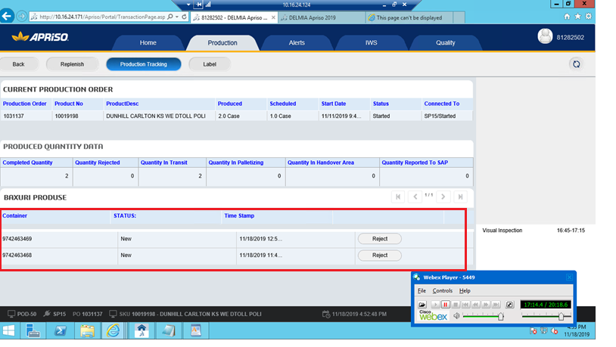

**Component 6.** **SMD_OPP-10_OP_View current PO data for maker**

6.1. Navigate to Operator portal 🡪 insert the work center 🡪 click on OK

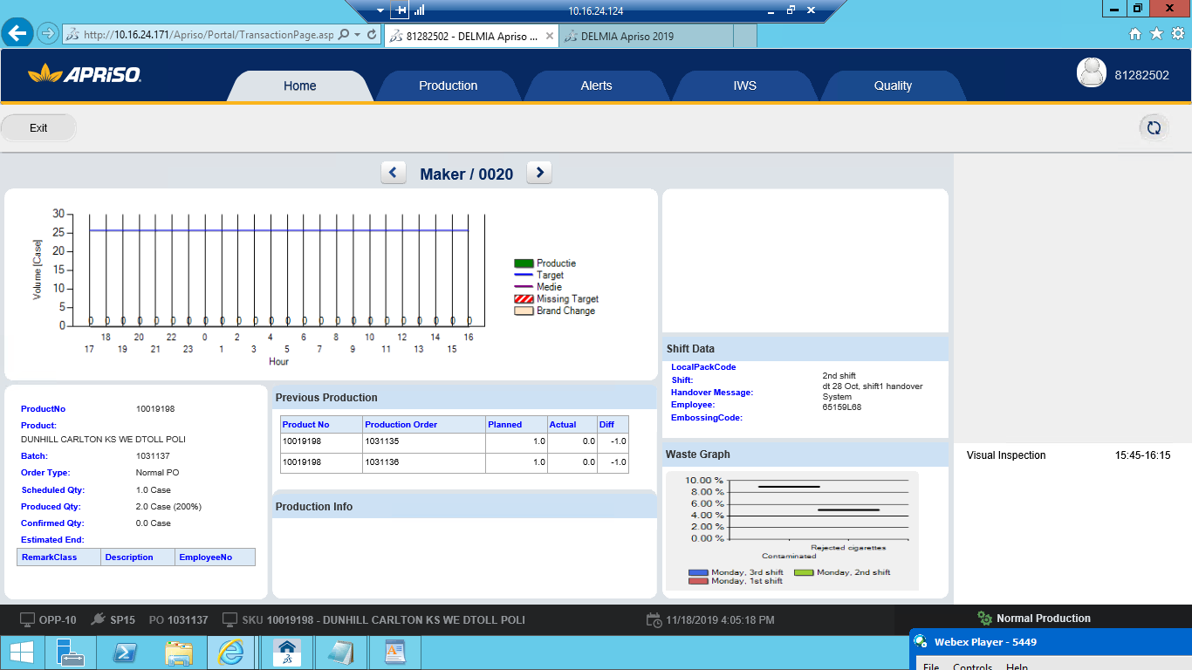

6.2. Navigate to “Make” Operation 🡪 Capture “ProductNo, Product, Batch, OrderType,

Scheduled Qty, Produced Qty, Confirmed Qty, Estimated End” and MCM Info grid details.

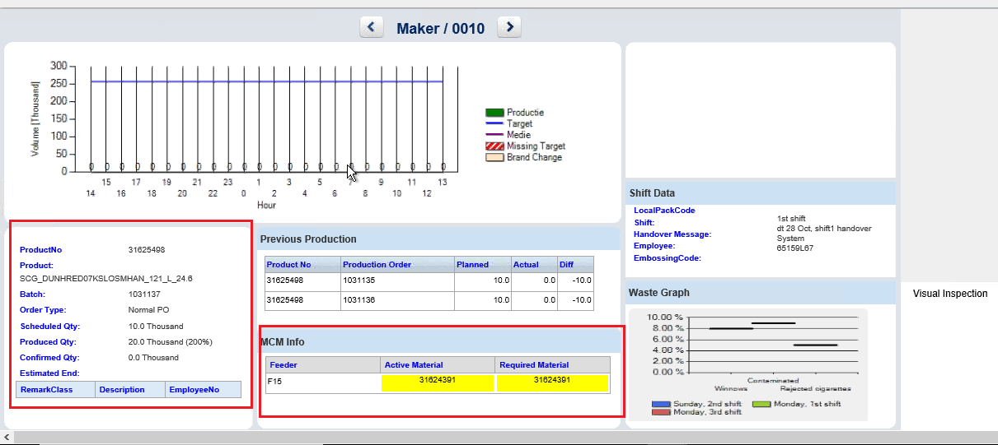

**Component 7.** **SMD_POD-10_OP_Display performance graph for current shift**

7.1. Navigate to BAT Operations 🡪 UIUX Operations 🡪 Operator Portal and Verify the

production from shift performance graph

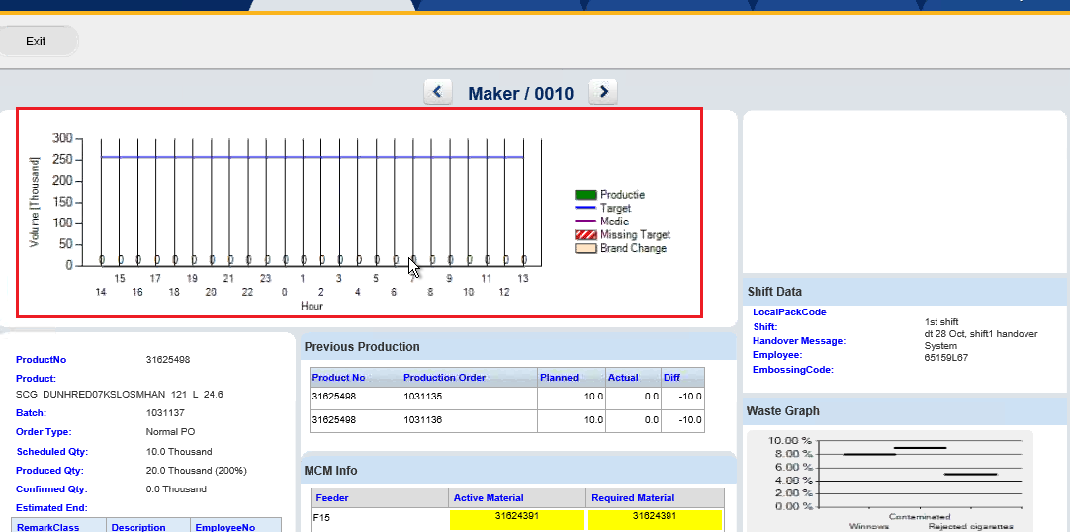

**12 Appendix**

